How to Check Password Strength with Python

1. Enter the following code pip install zxcvbn

I encounter an issue because my system is configured to use an externally managed Python environment, common in distributions like Kali Linux. This prevents directly installing Python packages system-wide using pip. Let's resolve this by creating a virtual environment for the project.

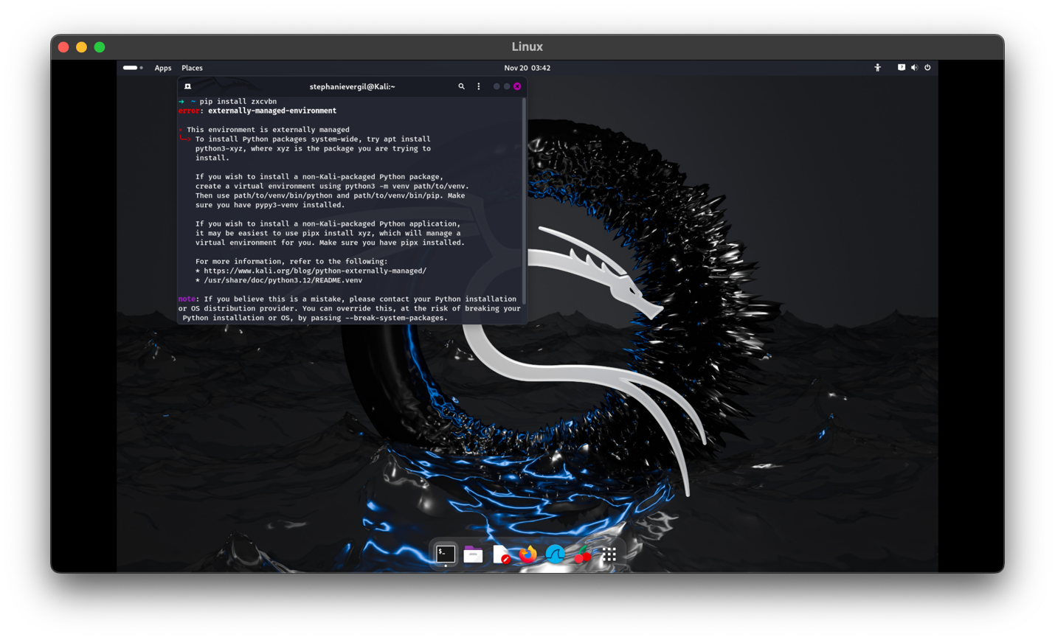

1. To create a virtual environment in a folder named myenv enter the following command

python3 -m venv myenv

1. Enter the following command to activate the virtual environment

source myenv/bin/activate

1. Now we can try again entering the following command to isntalll the zxcvbn Phyton library with the virtual environment using pip

pip install zxcvbn

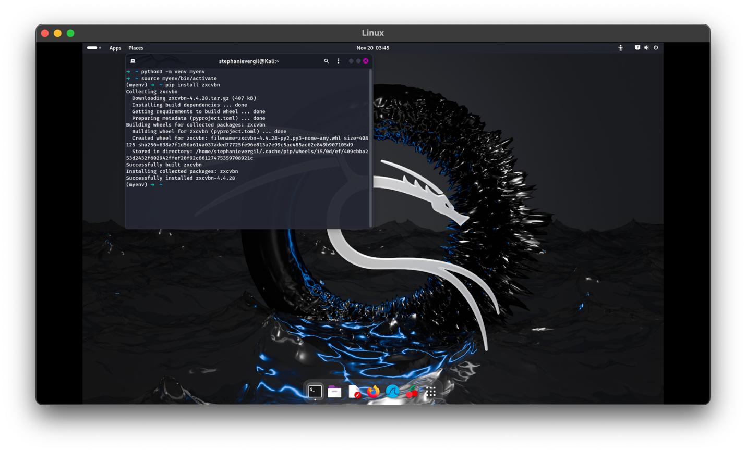

1. Enter the following command to create/edit a python script using the text editor nano

Nano check_password_strenght.py

Original script: 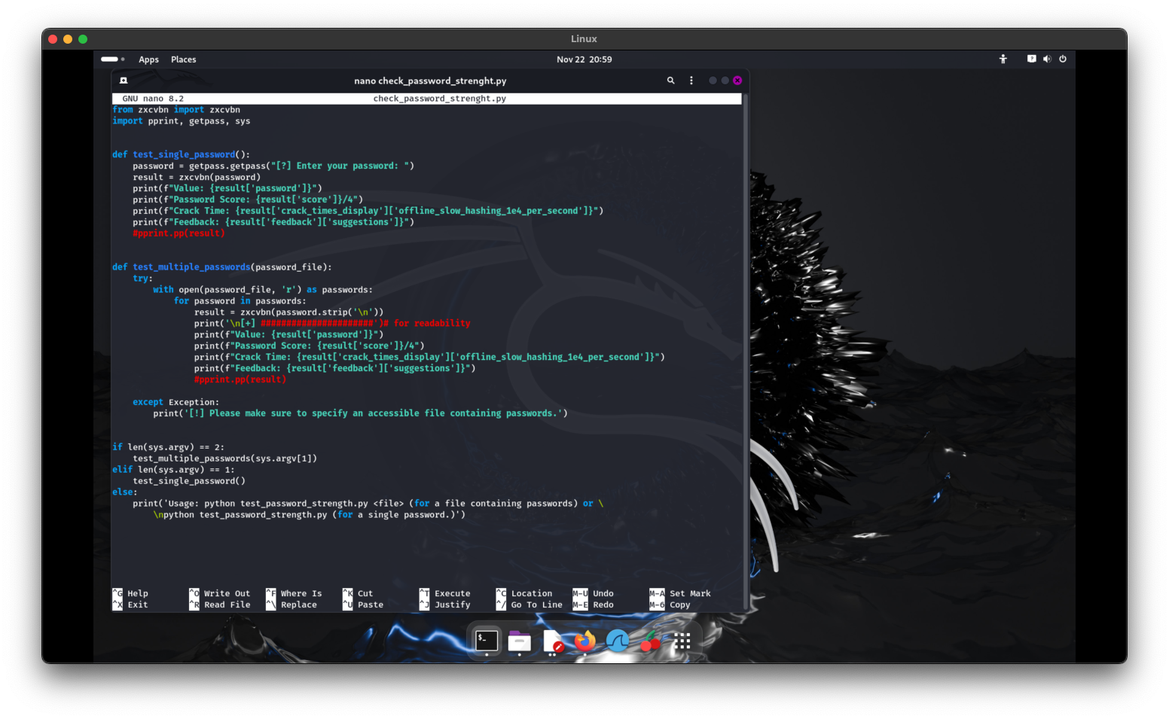

Improved script: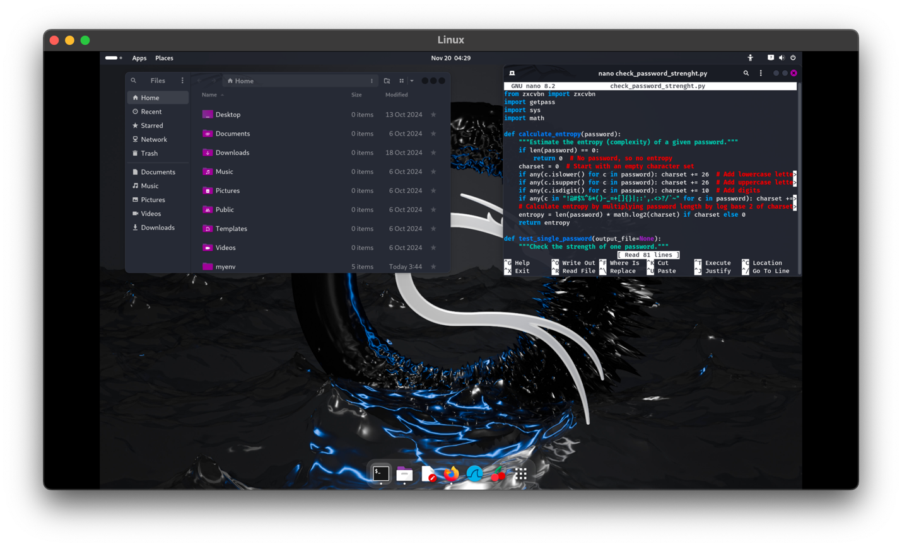

1. Now let’s create a .txt file using nano with many passwords stored entering the following command

nano passwords.txt

(type in passwords in text editor)

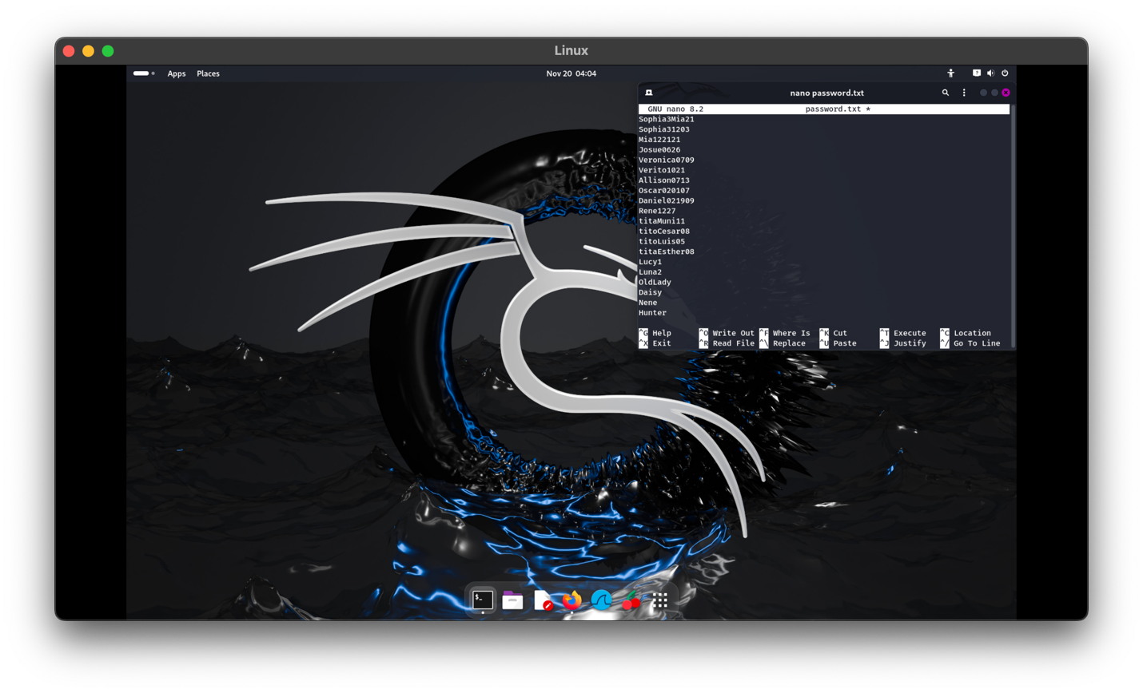

Original scrip:

Note how it doesn’t populate entropy, nor gives the option to save.

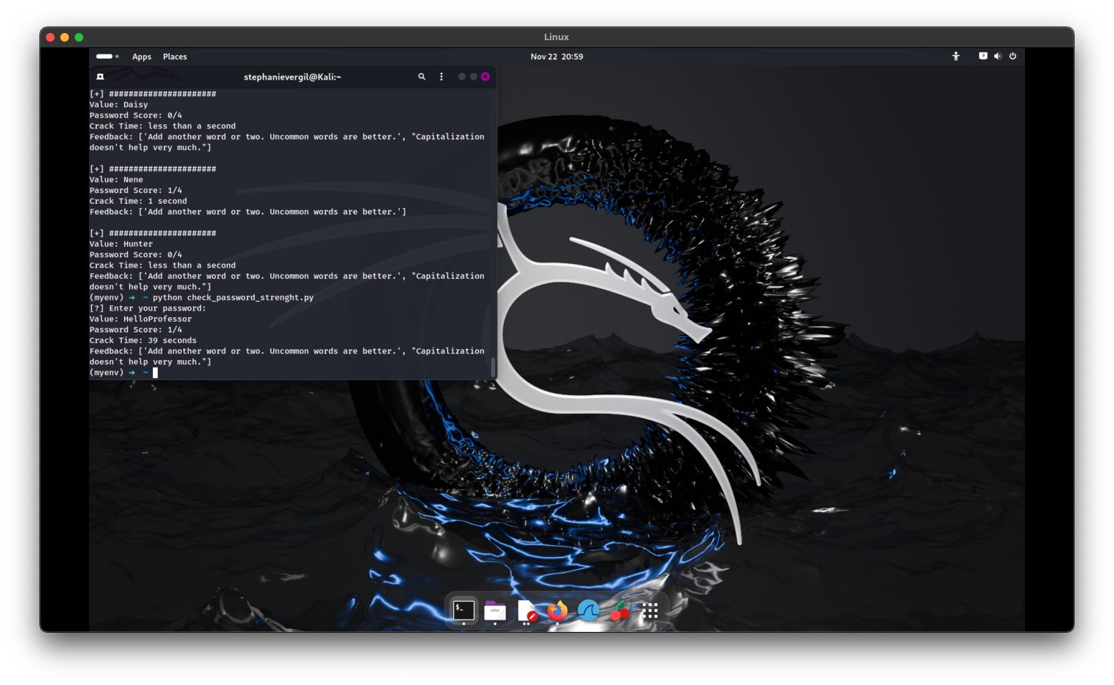

Improved script:

Showing the Entropy and options to save. To save enter the following command with the name of the file where password list is located at and name the file. In my case:

python check_password_strenght.py passwords.txt luis

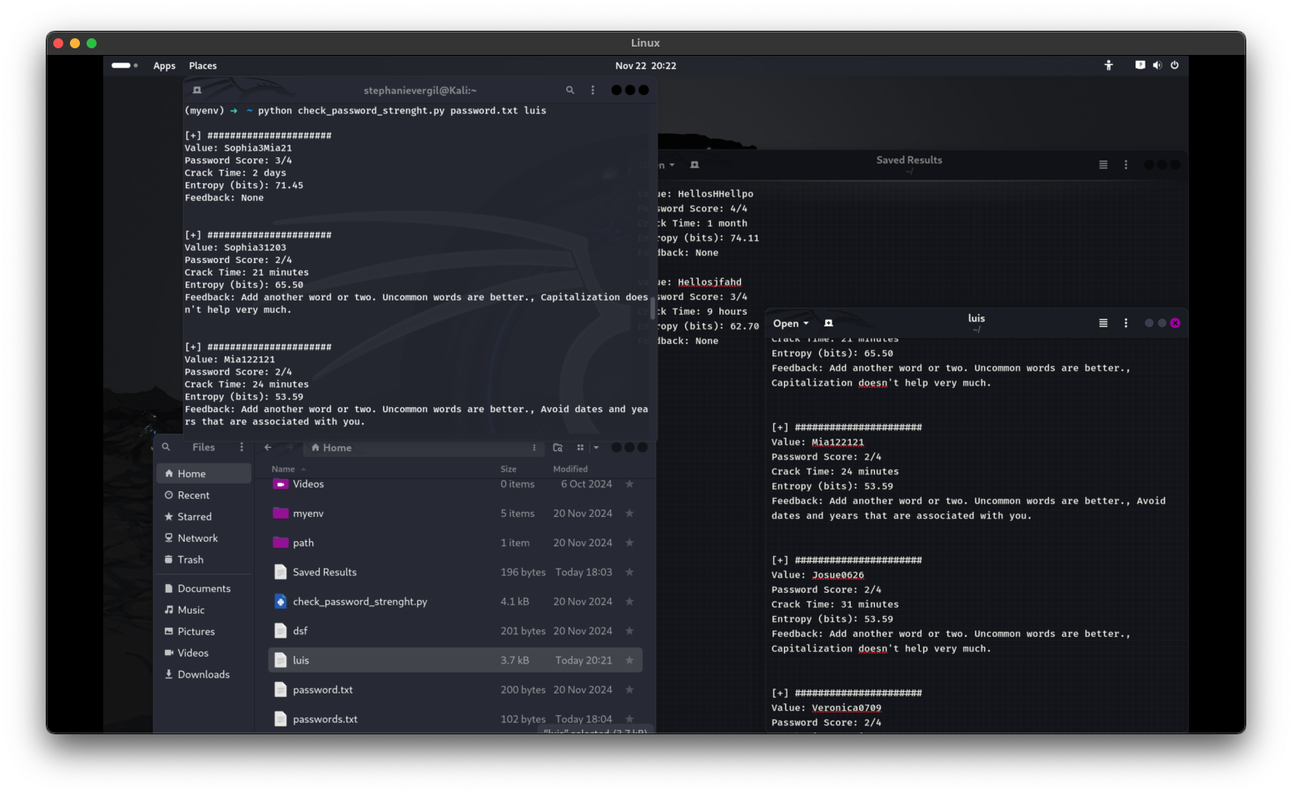

1. To test a single password, enter the following command

Python check_password_strengjt.py

Original script:

Again, it doesn’t provide a way to save only to view in terminal with no entropy



Improved script:

Provides the option to save file or to press enter to skip and not save, as mentioned the improved script comes with entropy calculations for determining passwords strength.

Here I saved two individual password results to the same file named Saved Results. Another example was that I saved an individual password strength result to the file named passwords.txt

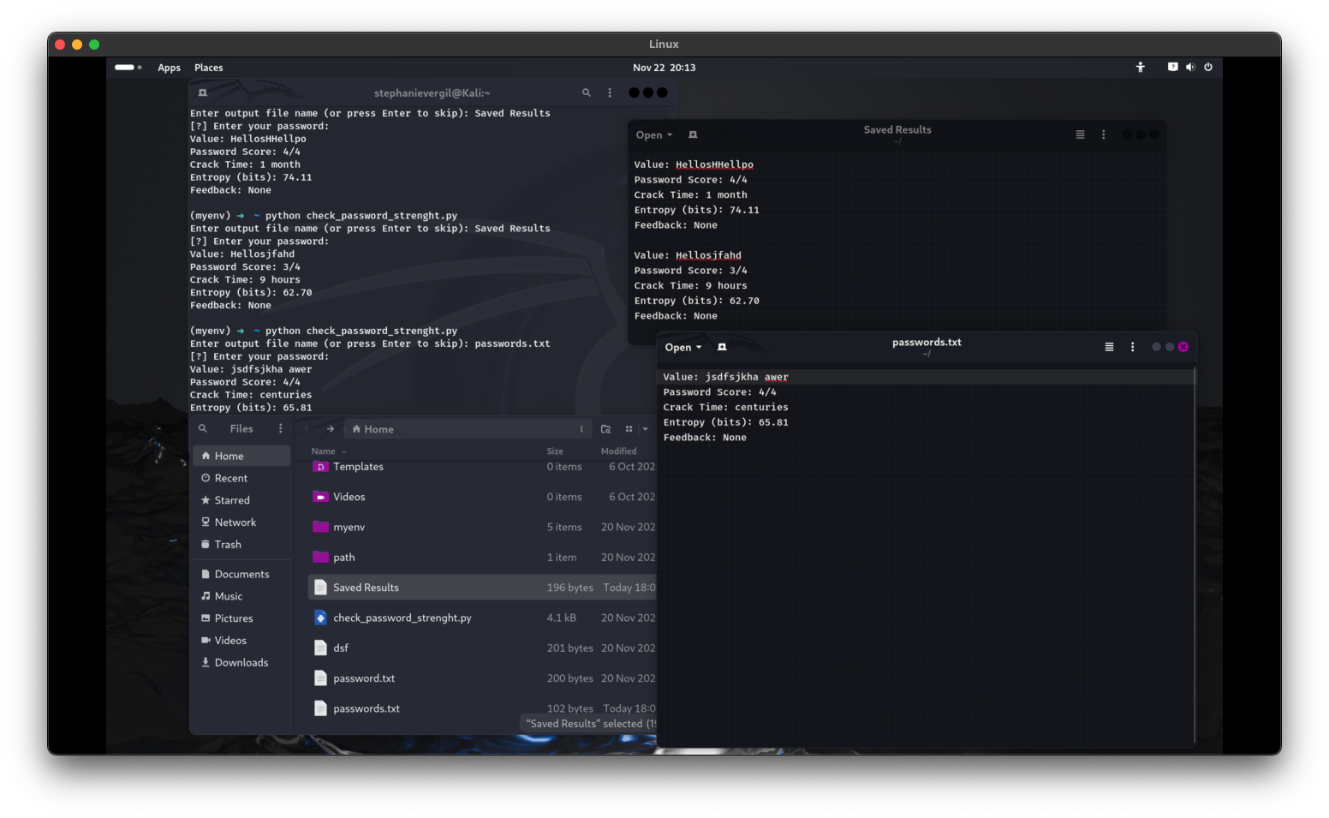

1. Once done don’t forget to deactivate the virtual environment, to return you to the system's default Python environment. After running deactivate, your terminal prompt will no longer include (myenv) to indicate the virtual environment is inactive.

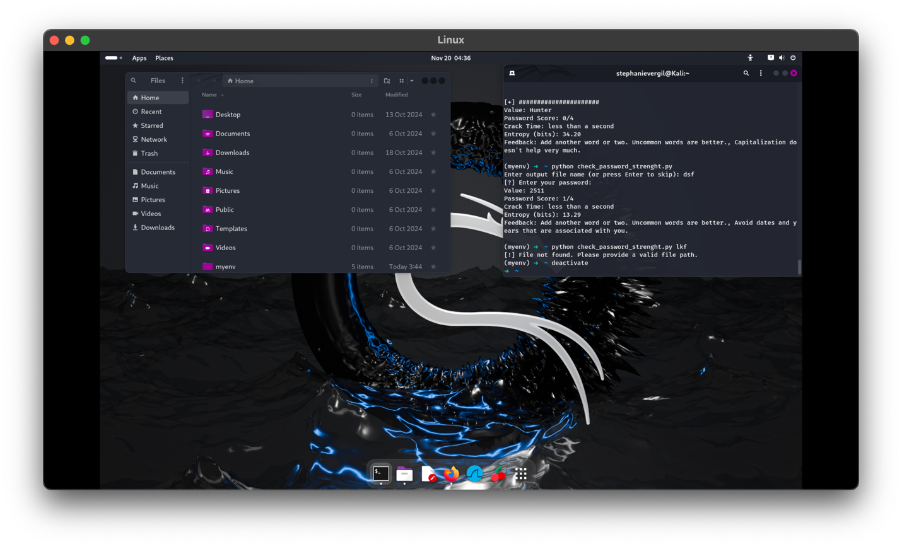

The original script checks how strong a password is using the zxcvbn library. It can test one password or many from a file. It shows the password's score (0–4), how long it might take to crack, and gives tips to make the password stronger. However, it doesn’t include extra details like password complexity (entropy) or the option to save the results.

The improved script calculates password entropy, which measures how complex and unpredictable a password is, providing deeper insight into its strength. The script also allows you to save the results to a file. When checking one password, you can simply run the command like this:

python check_password_strength.py

It will ask you to enter a file name to save the results or press Enter if you just want to view them in the terminal.

For checking multiple passwords, you can specify the output file by including the file name in the command, like this:

python check_password_strength.py password.txt luis.txt

This will save the results to luis.txt. If no output file is provided, the results will just be shown in the terminal.

Additionally, the improved script organizes the output better, making it clearer and easier to read when testing many passwords. Making the script more useful for understanding password security and easier to use for bulk password analysis.

Resources

* Abdullahi, Muhammad. “How to Check Password Strength with Python - the Python Code.” Python Code. <https://thepythoncode.com/article/test-password-strength-with-python>.